DPAU Cheat Sheet

Username: ext-XXXX
Email: ext-xxxx@monash.edu

- DPAU website (general information): https://www.dementiasplatform.com.au/
- DPAU Data Portal (metadata and application): https://portal.dementiasplatform.com.au/

Analysis Environment
- Account Activation Guides: https://www.dementiasplatform.com.au/sites/default/files/documents/DPAU_Account_Activation_Guides.pdf
- CISCO AnyConnect VPN
Address: vpn.monash.edu
Login: Username, password and Okta
- Open in browser: https://serp-web.erc.monash.edu/ to launch platform
Login: Username, password
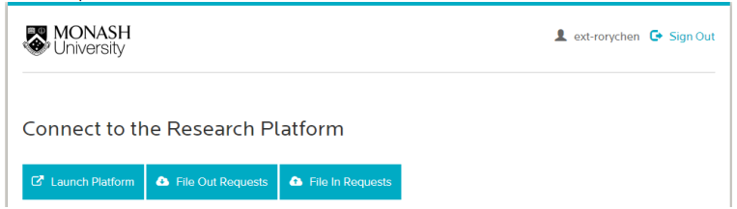

- Analysis Environment User Guides: https://www.dementiasplatform.com.au/research-hub/analysis-environment-guides
- Other Supporting Documents: https://www.dementiasplatform.com.au/research-hub/data-portal-supporting-documents

Contact information

safehavens@monash.edu | dpau@unsw.edu.au
- Account activation  - VPN  - Unable to log-in  - Cannot see P/U drive in the Virtual Desktop  - Install packages | - All other project-related issue

